 |  | Newent Doctors Practice at Holts Health Centre, Watery Lane
Improving the health, well-being, and lives of those we care for by providing a high-quality patient centred service for our community.  Our website is https://newentdoctors.nhs.uk  To contact us:  Please see the website or contact reception |  | A quarterly Newsletter Issued by the Practice
Introduction
Hello again. This is our fourth quarterly newsletter. We hope that you found the previous ones issued to be interesting and informative.
The newsletter is aimed at all of our patients and carers and a reminder that its purpose is twofold:-
1) To keep you better informed about what is happening at the surgery now and in the future
2) To provide you with a mechanism for making observations about your patient experience and to make suggestions regarding how you think things at the Surgery could be improved.
Whilst we operate under our own small business constraints, in addition to conditions imposed by the NHS, our objective is always to maximise the service provided to you and to treat all suggestions with consideration. We will always aim to convey our reasons for any resultant action taken or not taken.
We had hoped to be able to distribute newsletter updates by email to all of our patients. Unfortunately, to date, this has not been possible but copies will be available at the Surgery, also Manna House Coffee shop, Day Lewis Chemist, Red Lion Pub, Newent Library, Kings Arms Pub, Newent Community Centre, Erols Courtyard Café and Old Shambles Charity Shop.
Our thanks to these establishments for supporting the Surgery. It is our intention to extend this list in the future. Unfortunately, we are not able to post or deliver paper copies to individual addresses.

 |  | The practice
Our website is https://newentdoctors.nhs.uk  To contact us:  Please see the website or contact reception |  | 
Deborah Vernon-Hughes (Practice Manager)  Doctors :- Stenson, Underwood, Rees, Dargan, Harper, Baxter, Zatman, Cottam, Bennion, Arden-Thomas |  | Are your contact details up to date?  Unless we have your up to date contact details, you may not receive important telephone calls, text messages or even letters from the practice and other organisations. Please let reception know if your details have changed or visit our website to update your personal details.  https://newentdoctors.nhs.uk/services/managing-your-health-online/online-forms/change-your-personal-details/  Breast screening  Had an invite for breast screening? Make sure you mark the date in your diary!  Breast screening uses a test called mammography which involves taking X-rays of the breasts. Screening can help to find breast cancers early and these cancers are usually easier to treat than larger ones.  It’s important to remember that screening won’t prevent you from getting breast cancer but it aims to find early breast cancers.  Regular breast screening is one of the best ways to spot a cancer that’s too small to feel or see yourself. It saves around 1,300 lives each year in the UK!  Don’t ignore your invite when it lands on your doorstep!  https://campaignresources.dhsc.gov.uk/campaigns/help-us-help-you-cancer/breast-screening-saves-lives/

Are you a Carer?
Many people don’t recognise themselves as Carers, they see what they do as “helping out,” supporting a family member, friend, or neighbour. However, early identification is key to ensuring Carers receive timely support, information, and guidance.
You may be a Carer if you regularly support another person with tasks such as:
- Shopping or running errands
- Collecting prescriptions or managing medication
- Cooking meals or preparing food
- Helping with household tasks
- Checking in on someone regularly to make sure they’re safe or coping
- Providing emotional support
- Supporting someone to attend appointments
- Managing finances or paperwork
Please let reception know if you are a carer as identifying a Carer early helps:
- Prevent escalation of stress and burnout
- Improve wellbeing and resilience
- Ensure access to local support, training, and community connections
- Empower them with knowledge of their rights and options
Did you know that you can meet with other carers at Guideposts CONNECT Carers Group at the Community Pavillion, Newent, GL18 1QA, every last Tuesday of each month, 1pm-3pm. 01452 529697 or 07850 204910 to find out more
Building the NHS of the future
Help build a health service for your future and the future of your family.
A recent report found that the NHS was in a critical state, and the Government wants to hear the public’s views on how the NHS can adapt to the changing demands of today.
Make sure you give your views and opinions on the health service, its future and the 10-Year Plan for Health. Don’t miss your chance to shape the future of the NHS.
https://campaignresources.dhsc.gov.uk/campaigns/change-nhs/

Ovarian Cancer Awareness Month, 1st–31st March
Feeling bloated? Need to wee more? Feeling full? Unexplained tummy pain? Raising awareness of ovarian cancer is vital in improving early diagnosis. Currently, just one in five women can name bloating as a symptom of ovarian cancer.
Ovarian Cancer Awareness Month highlights the importance of picking up on early changes. Two-thirds of women are diagnosed with ovarian cancer too late, when the cancer is harder to treat. We need to change that! If you have any of these ongoing symptoms, make an appointment with your GP.
#EarlyDiagnosisSavesLives
This video explains more:
https://www.youtube.com/watch?v=D5z1JUnRSe4
Stop Smoking
Did you know, by quitting smoking, you could save around £2,500 per year? Not only will your wallet benefit, but you’ll notice almost immediate improvements in your health.
National No Smoking Day may have passed, but every day is a good day to stop. Quitting smoking is the best thing you can do and it’s never too late to give it a try. Support is vital in helping you succeed and in maintaining a smoke-free future.
Managing cravings and coping with triggers can help avoid relapsing. Cravings can be triggered by stress, habits and lifestyle reminders. Being aware of your triggers helps you manage cravings when they strike.
- https://www.nhs.uk/better-health/quit-smoking/
- https://www.nhs.uk/better-health/quit-smoking/staying-smoke-free/understand-your-smoking-triggers-and-cravings/
The Gloucestershire Healthy Lifestyles Services Team provide support to those trying to stop smoking.
They offer free one-to-one support from their friendly coaches over a 12-week period.
75% of people who have used the service have become smoke-free.
Those wishing to use the service can self-refer or be referred by a healthcare professional https://secure2.1s4h.co.uk/Glos/glos.html
For more information visit the Healthy Lifestyles Gloucestershire website https://hlsglos.org/stop-smoking/
or Tel: 0800 755 5533

A Day in the Life of a GP Receptionist
Our GP receptionists are the first point of contact for our patients and highly valued members of staff at the very heart of the practice.
Here’s what a typical day looks like for one of our receptionists – we’ll call her Janet.
7:55am
I arrive at the practice, turn on all the computers, log in, complete my early morning jobs and prepare for the phones to start. As soon as the lines open, the day will begin at full pace.
I start rearranging appointments because a clinician has called in sick, dealing with online queries, and answering the door for anyone who needs access between 8:00 and 8:30am.
8:30am
My colleagues arrive, so I move away from the front desk while they take over face-to-face enquiries and phone calls — booking appointments with the appropriate clinician or signposting patients to the right services.
I begin working through the electronic mail that has arrived overnight, carefully reviewing and forwarding (work flowing) each item to the appropriate team member within the practice.
11:00am
Between incoming phone calls, the next hour and a half is dedicated to responding to online enquiries. These can range from routine appointment requests to general queries. Every single one must receive a response by 6:30pm that same day.
During this time, I also process new patient registrations and arrange referrals to district nurses.
1:00–1:30pm
I manage a quick sandwich for lunch before heading back to the front line.
1:30pm
I return to the front desk, supporting patients face-to-face, answering enquiries, booking appointments, and dealing with tasks from GPs and nurses — and much more besides.
A workman arrives to fix the lift, so I sign him in and ensure all procedures are followed.
6:15pm
As the day winds down, I begin checking the building, closing down rooms and ensuring everything is safe and secure for the night, while my colleague continues answering calls.
6:25pm
I carry out one final check of online enquiries to make sure we’ve responded to everything before the 6:30pm deadline.
6:30pm
I finish for the day and lock up with my colleagues

Patient Participation Group (PPG)
A message from the Chair
Defibrillators
“Automatic External Defibrillators” (AEDs) save lives. In situations where somebody is even just suspected to be in cardiac arrest, the person trying to resuscitate them will need to send someone to fetch the nearest AED. That could be you. In Newent you have three choices: (a) the big Co-op; (b) the Library; and (c) on the wall of the Community Centre at the Kings Arms end. If you’re not in Newent, call 999 for the location. Either way, call 999 to get the code for the lock.
Maybe you’ll be the person who needs to use the AED when it arrives. If so, don’t worry: it will guide you with voice prompts. It is designed to be safe for untrained people to use, won’t administer a shock if it detects a heartbeat, and even adjusts for you putting on the electrode pads the wrong way around. Just be sure to warn people to stand clear when it tells you to do so. After the AED has administered a shock and detected a heartbeat, it will even sound out the rhythm for chest compressions and tell you when to give “rescue breaths”. Remember: if someone is unconscious and not breathing, they are going to die. Nothing you do can make that worse, so go for it.
If you haven’t used an AED before, watch an online demonstration today. Just search for “aed demo video uk”.
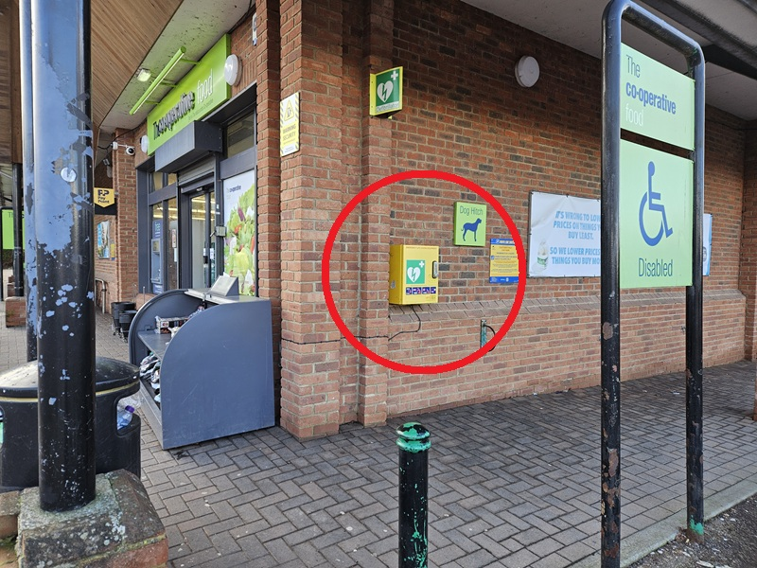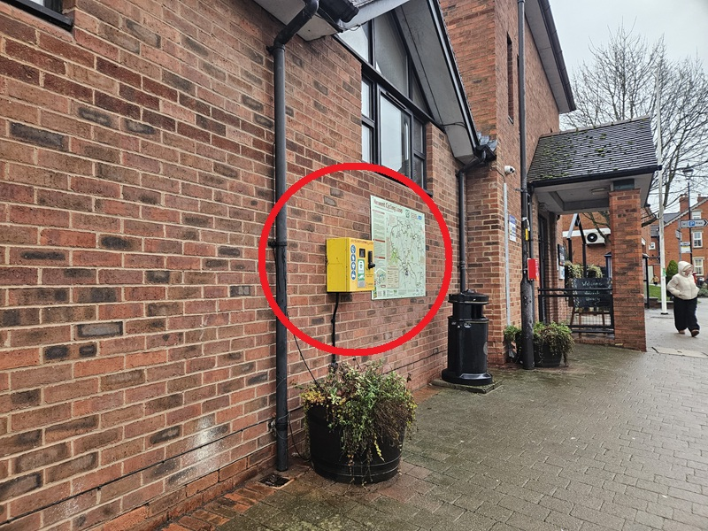
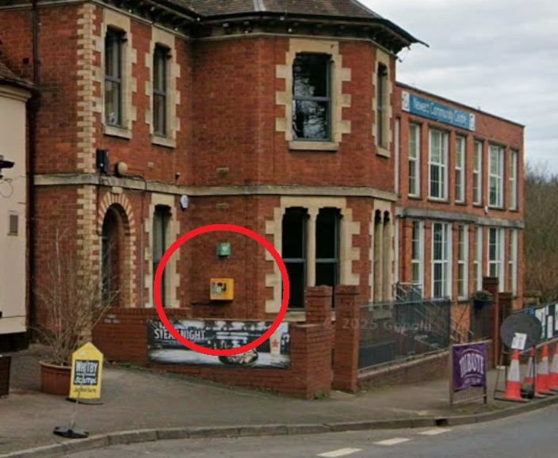
Vilnis Vesma

V2 (ed. VV) 25/03/26
Contact us
Use the QR code
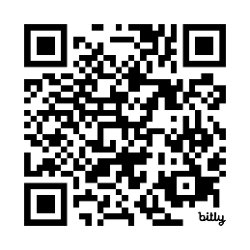
Our website is:
bit.ly/newent-ppg
Our email address is:
newentppg@mailpilot.net

