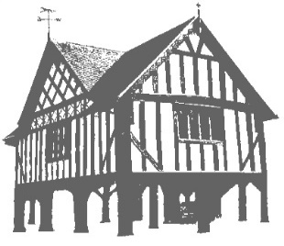 Newent Doctors Practice

The Holts Health Centre, Watery Lane, Newent, Gloucestershire, GL18 1BA.

CONSENT FOR SHARING OF MEDICAL INFORMATION

**Name:**

**Address:**

**Date of Birth**:

I agree for the following person(s) or organisation(s) to make queries regarding my health/investigations/treatment, collect prescriptions/medication and for the GP and/or authorised GP staff to share relevant information/advice in the interests of my health care.

**Please indicate A or B**

**A - This consent is restricted to the following query/request**: …………………………………………………………………………………………………………………………….. ……………………………………………………………………………………………………………………………..

B - **This consent applies to all queries as of the date of this form that the GP/staff reasonably believe is in the interests of my best health care.**

**Person(s)/Organisation(s):**

Relative (state name and relationship) ……………………………………………………………………………………………………….........................

Carer (state if friend or carers in an organisation) ………………………………………………………………………………………………………………………...

Community-Based Health Care Providers (e.g., nurse, dentist, optician, chiropody, physio, speech/language, appliances) Please give details ……………………………………………………………………………………………………

Community-Based Social Care Providers (e.g. social services, safeguarding, local support service) Please give details .……………………………………………………………………………………………………

School/Young Person-relevant Care Providers (e.g. teachers, school nurse, health visitor, CAMHS, sexual health care) Please give details .…………………………………………………………………………………………………..

Other (state who) ………………………………………………………………………………………………..

The following conditions will apply: • The GP/staff will only share the minimum information needed to address the query made • The GP/staff will only share information they believe to be in the best interests of my health • The GP/staff will not have future control over the storage/use of this information by the person(s)/organisation(s) above**. If I wish to rescind this consent at a future date, I will do so in writing to: “Newent Doctors Practice”. A copy of this form will be retained in my medical record. Further information about the Medical Centre Privacy Policy can be found on the practice website. Signed………………………………………………… Date ………………………..**

Please bring the completed form to reception, you will need to show one form of ID.

If your representative is handing the form in for you, they will need to bring 1 form of your ID as well as 1 form of their own ID.

One piece of evidence must include a photograph. If no photo evidence, please see acceptable ID below.

**Acceptable Identity evidence:**

Passport

Driver’s licence

Birth certificate

Adoption certificate

Utility bill

Firearm certificate

Marriage certificate

UK asylum seekers Application

Residential property rental or purchase agreement

**For Office Use Only:**

ID Seen YES / NO – Please circle above types of ID seen initial______ Date _________